MD2201: Data Science

Name of the student: Rajeev Tapadia Roll No.: 67

Div: C Batch: 3

Date of performance:

Experiment No.1

Title: Laboratory on Data Visualization
Aim: i. To explore the dataset for different case study examples with different commands.
ii. To plot the Box plot and scatter plot.

Software used: Programming language R.

Code Statement:
- Write a single R code to display the answers for the following questions.

Case Study: Consider the “pollutant” data set.

- What is the mean of “Temp” when “Month” is equal to 6?
- How many observations are there in the given data?
- Print last two rows of the data.
- What is the value of Ozone in 47th row?
- How many values are missing in Ozone column?
- What is the mean of Ozone column excluding missing values?
- Extract the subset of rows of the data frame where Ozone values are above 31 and Temp values are above 90. What is the mean of Solar.R in this subset?
- What was the maximum ozone value in the month of May (i.e. Month is equal to 5)?

# 1. Mean of Temp when Month is 6
mean(pollutant$Temp[pollutant$Month == 6])
# 2. Number of observations
nrow(pollutant)
# 3. Print last two rows
tail(pollutant, 2)
# 4. Ozone value in 47th row
pollutant$Ozone[47]
# 5. Missing values in Ozone
sum(is.na(pollutant$Ozone))
# 6. Mean of Ozone excluding missing values
mean(pollutant$Ozone[!is.na(pollutant$Ozone)])
# 7. Mean of Solar.R for Ozone > 31 and Temp > 90
mean(pollutant$Solar.R[pollutant$Ozone > 31 & pollutant$Temp > 90])
# 8. Maximum Ozone value in May (Month = 5)
max(pollutant$Ozone[pollutant$Month == 5])

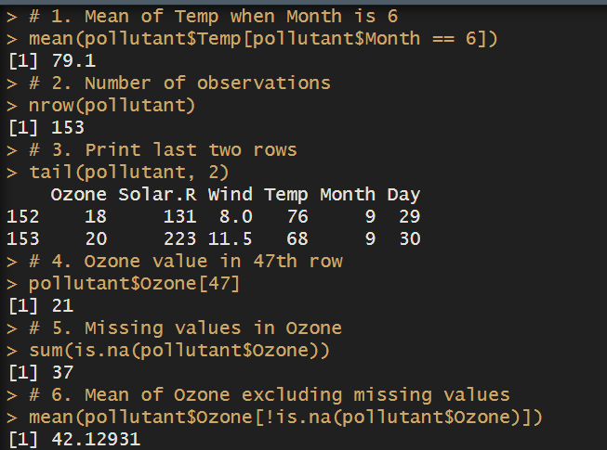

- Write a single R code to display the answers the following questions

Case Study: Hair Eye color Data set

- How many people have brown eye color?
- How many people have Blonde hair?
- How many Brown haired people have Black eyes?
- What is the percentage of people with Green eyes?
- What percentage of people have red hair and Blue eyes?
- # 1. How many people have brown eye color?
- brown_eye <- subset(dataset, dataset$Eye.Color == "Brown")
- nrow(brown_eye)

- # 2. How many people have Blonde hair?
- sum(dataset$Hair.Color == "Blonde")

- # 3. How many Brown haired people have Black eyes?
- sum(dataset$Hair.Color == "Brown" & dataset$Eye.Color == "Black")

- # 4. What is the percentage of people with Green eyes?
- green_eye_percent <- sum(dataset$Eye.Color == "Green") * 100 / nrow(dataset)
- cat(green_eye_percent, "%")

- # 5. What percentage of people have red hair and Blue eyes?
- sum(dataset$Hair.Color == "Red" & dataset$Eye.Color == "Blue") * 100 / nrow(dataset)
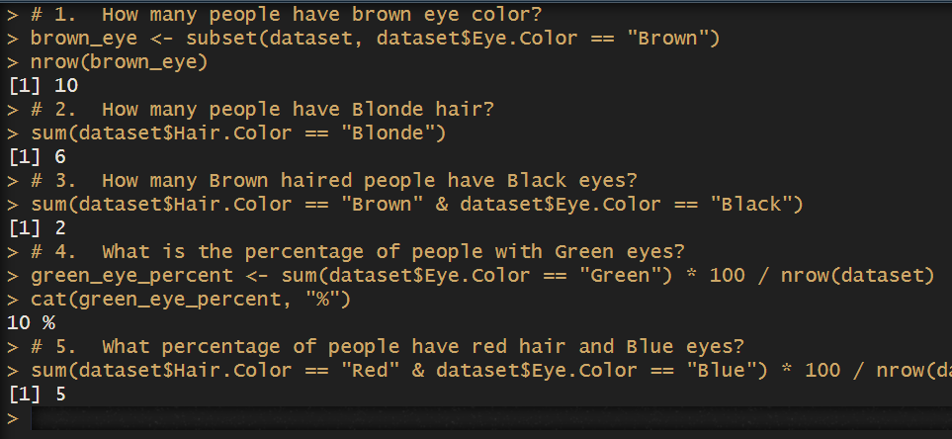

- Write a single R code to display the answers for the following questions

Case study: Germination Data Set

- What is the average number of seeds germinated for the uncovered boxes with level of watering equal to 4?
- What is the median value for the data covered boxes?
- # 1. avg no of seeds germinated for uncovered boxes with watering 6?
- subset1 <- subset(dataset, dataset$Box == "Uncovered" & dataset$water_amt == 4)
- mean(subset1$germinated)

- # 2. What is the median value for the data covered boxes?
- covered_boxes <- subset(dataset, dataset$Box == "Covered")
- median(covered_boxes$germinated)

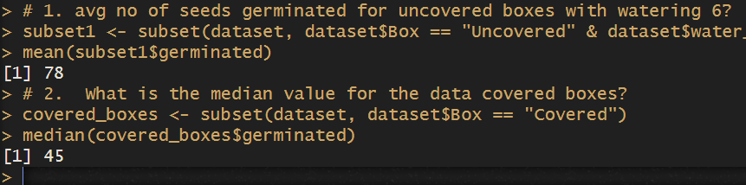

- Write a single R code :
- To display the Boxplot for sepal length of iris data set as shown below
- To display the Scatter plot for murders data set present in “dslabs” package as shown below.

Give proper title, x,y axis label etc. to each plot.
# plot using ggplot2
ggplot(data = iris, aes(x = Species, y = Sepal.Length, )) +
geom_boxplot(aes(fill = Species)) +
ggtitle("Box Plot")

Expected Boxplot:
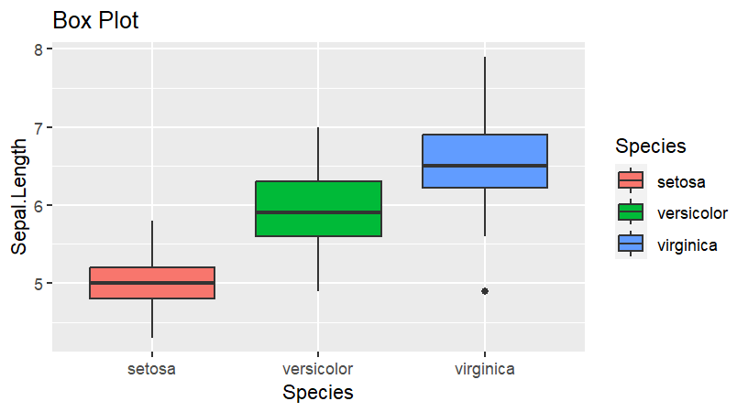

Expected Scatter Plot:
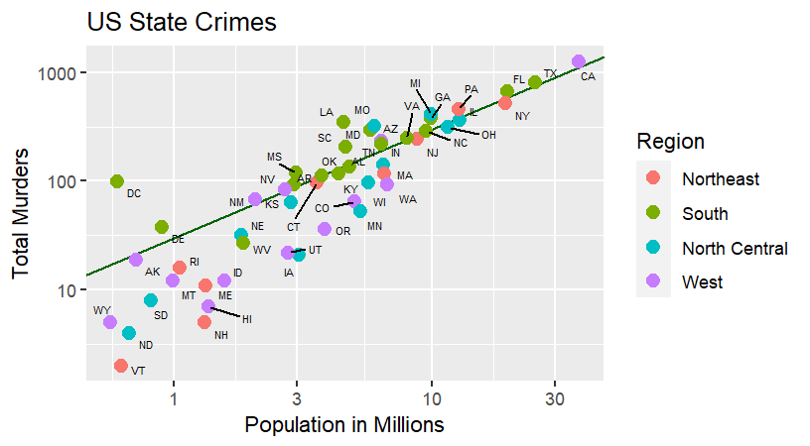

ggplot(murderdf, aes(x = population/ 10^6, y = total)) +
geom_abline(intercept = log10(r), col = "darkgreen") +
geom_point(aes(color = region), size = 3) +
geom_text_repel(nudge_x = 0.005, size = 2, aes(label = abb)) +
scale_x_log10("Population in Millions") +
scale_y_log10("Total Murders") +
ggtitle("US State Crimes") +
scale_color_discrete(name = "Region")

